Chassis and Axle: Building Race Cars

Subject:  Related Subjects: | Grade Level(s): 4  Length of Lesson: | Type: Inquiry / Design / Project  Keywords: Chassis; axle

Lesson Overview
Use this section to describe at a high level what the lesson is. Should be no more than 3-4 lines.

Lesson Focus
What is the central question or phenomenon being investigated? What problem are they trying to solve?

Lesson Objective(s) | Students will learn how a chassis and axle work in a car.  - Create a basic chassis for a push-propelled car using foamboard and dowels  - Create two axels and wheel pairs and attach to car  - Demonstrate that car can move forward, in a straight line, in response to a starting push

Lesson Timing

5 minutes | Introduce the Lesson
30 minutes | ...

Materials | - Foam board, long dowels (for body of car)  - Dowels and straws for axle design  - Wheels  - Scissors  - Tape/glue
Instructor Prep | - Step 1
Related Resources | - List related lessons/ppts etc available from USC or outside, trusted orgs

Lesson Plan

Introduction
The chassis and axel are two critical components of a car.
- Chassis: Framework of the car. Holds everything together. We can think of the chassis as the skeleton of the car.
- Axel The axel is a central shaft for a rotating wheel. The axel can be fixed to, and rotate with, the wheels, or the wheels can rotate around the axle. We typically have two wheels per axle, and two axles per vehicle.

Procedure
Building the chasis
- Students will construct the framework of their car using foam board and two long dowels (as shown below).
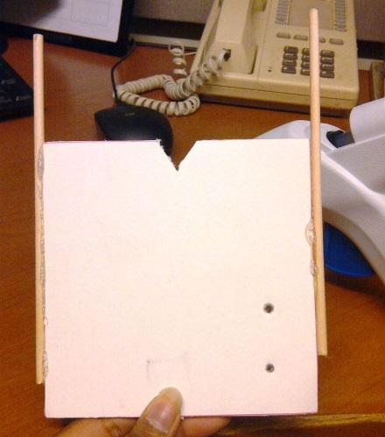
- In their design, students will make sure that their chassis allows their car to drive in a straight line. To do this, the chassis should be set up such that the axels that turn the wheels are parallel (go through a refresher of what parallel means). Shown below are potential car designs. Four designs (some with parallel wheels and some without) will be drawn on the whiteboard. Students will use plicker cards to select car designs that will be able to drive in a straight line by recognizing cars with parallel axles.
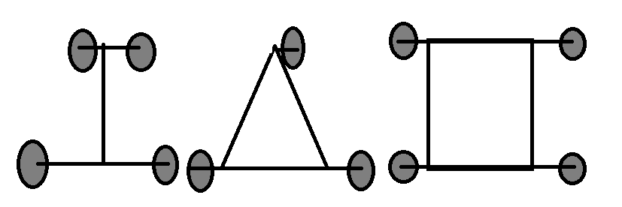

Building and attaching the axles
- Students will fabricate axels (either fixed or rotating) and two wheel pairs, and attach them to the foam board car body. Axles can be made by inserting a straw into a dowel and attaching the straw to the car body.
- A successful design will demonstrate that all four wheels can turn and that the car can roll straight in response to a push from the student. Students can improve on their designs until these requirements are fulfilled.
- If all students build working models and there is time remaining, students will have a chance to optimize their designs or use markers to decorate their cars.

Wrap-up
Incorporating a motor – preview for next week
- In a real car, we have two sets of wheels. One set is controlled by our engine, and rotates in response to us pushing the gas pedal. The other set of wheels spins freely so the car can move. We want to design our car in the same way – we need one fixed axle and one that is free to rotate. Students will examine their car design and think about how they could incorporate a spinning motor to power their car. If they need to, they can adjust their designs to allow them to move in response to an attached motor. Have the students determine where on the car they would put the motor and how the spinning motor could drive the axle.
- Next week: Attach a motor to the car and hold races. Give students time between races to modify and improve their designs. Set up a track that is straight and approximately one foot wide. To avoid disqualification in the race, the car must remain in its lane (drive straight). Students can adjust wheel alignment to make sure the cars stay in their designated lanes.

Lesson Background for Teachers

Suggested Real-World STEM Connections
- List possible related Role Models in STEM (with details and links to more reading). Give suggestions for examples of scientists/engineers who are from underrepresented groups in STEM in related careers.
- List related real-world engineering problems and examples

Lesson Variations and Options
Include descriptions of alternative methods or ways to present things.

Explanation
Describe the background concepts and explanations behind the lesson. This can be more in depth than a teacher/instructor would actually share with students.

Key Concepts and Vocabulary
- Word 1: Grade Appropriate Definition
- Word 2: Grade Appropriate Definition

Safety Notes
- Safety instruction

